Student Name: Sahil Hans UID: 25MCI10088
Branch: M.C.A(A.l & M.L) Section/Group: MAM-1 A
Semester: Second Sem Date of Performance:12/01/2026
Subject Name: TECHINCAL SKILLS Subject Code:

WORKSHEET 4
AIM: To understand and implement iterative control structures in PostgreSQL conceptually, including FOR loops, WHILE loops, and basic LOOP constructs, for repeated execution of database logic.
S/W Requirement: Oracle Database Express Edition and pgAdmin
OBJECTIVES:
- To understand why iteration is required in database programming
- To learn the purpose and behavior of FOR, WHILE, and LOOP constructs
- To understand how repeated data processing is handled in databases
- To relate loop concepts to real-world batch processing scenarios
- To strengthen conceptual knowledge of procedural SQL used in enterprise systems

Practical / Experiment Steps
Example 1: FOR Loop – Simple Iteration
- The loop runs a fixed number of times
- Each iteration represents one execution cycle
- Useful for understanding basic loop behavior
Application: Counters, repeated tasks, batch execution
Querry:
DO $$
BEGIN
FOR i IN 1..5 LOOP
RAISE NOTICE 'Iteration Number: %', i;
END LOOP;
END $$;

Output:
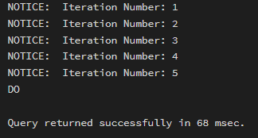
Example 2: FOR Loop with Query (Row-by-Row Processing)
- The loop processes database records one at a time
- Each iteration handles a single row
- Simulates cursor-based processing
Application: Employee reports, audits, data verification

For table – Violations
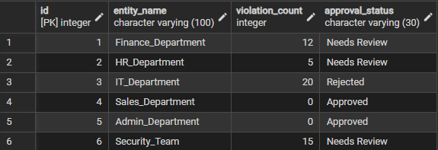
Querry:
DO $$
DECLARE
rec RECORD;
BEGIN
FOR rec IN SELECT entity_name, violation_count FROM Violations LOOP
RAISE NOTICE 'Entity: %, Violations: %',
rec.entity_name, rec.violation_count;
END LOOP;
END $$;
Output:
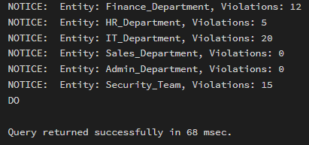
Example 3: WHILE Loop – Conditional Iteration
- The loop runs until a condition becomes false
- Execution depends entirely on the condition
- The condition is checked before every iteration
Application: Retry mechanisms, validation loops
Querry:

DO $$
DECLARE
counter INT := 1;
BEGIN
WHILE counter <= 5 LOOP
RAISE NOTICE 'Counter Value: %', counter;
counter := counter + 1;
END LOOP;
END $$;
Outcome:
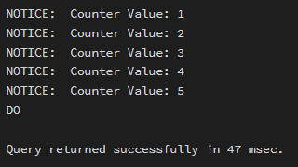
Example 4: LOOP with EXIT WHEN
- The loop does not stop automatically
- An explicit exit condition controls termination
- Gives flexibility in complex logic
Application: Workflow engines, complex decision cycles

Querry:

DO $$
DECLARE
counter INT := 1;
BEGIN
LOOP
RAISE NOTICE 'Loop Count: %', counter;
counter := counter + 1;
EXIT WHEN counter > 5;
END LOOP;
END $$;
Output:
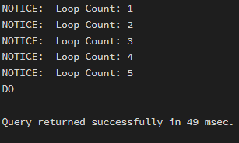
Example 5: Salary Increment Using FOR Loop
- Employee records are processed one by one
- Salary values are updated iteratively
- Represents real-world payroll processing
Application: Payroll systems, bulk updates
For table Employees
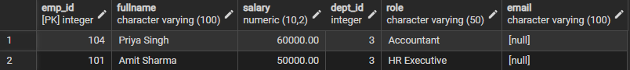
Querry:
DO $$
DECLARE
rec RECORD;
BEGIN
FOR rec IN SELECT emp_id, salary FROM Employees LOOP
UPDATE Employees
SET salary = salary - 1000
WHERE emp_id = rec.emp_id;
END LOOP;
END $$;
Output:
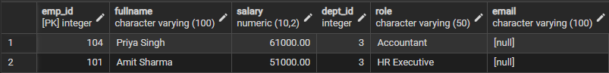
Example 6: Combining LOOP with IF Condition
- Loop processes each record
- Conditional logic classifies data during iteration
- Demonstrates decision-making inside loops
Application: Employee grading, alerts, categorization logic
For table StudentGrades
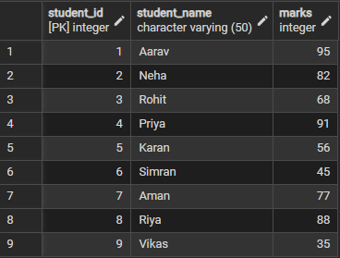
Querry:
DO $$
DECLARE
rec RECORD;
BEGIN
FOR rec IN SELECT student_name, marks FROM StudentGrades LOOP
IF rec.marks >= 75 THEN
RAISE NOTICE '% : Distinction', rec.student_name;
ELSE
RAISE NOTICE '% : Needs Improvement', rec.student_name;
END IF;
END LOOP;
END $$;

Output:
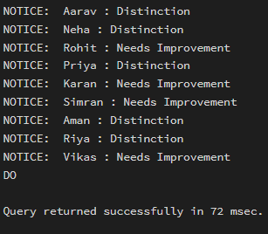
Result
This experiment helps students understand how iterative control structures work in PostgreSQL at a conceptual level. Students learn where and why loops are used in database systems and gain foundational knowledge required for writing procedural logic in enterprise-grade applications.

